**A**

**Project Synopsis Report**

on

**“Accommodation Solution for Students and Bachelors – ApnaPG”**

*Submitted in partial fulfilment for the award of degree*

*of*

**BACHELOR OF TECHNOLOGY**

*In*

**INFORMATION TECHNOLOGY**

Submitted by

**Pravin Mhaske (20141240)**

**Ayush Vaidya (20141217)**

**Amit Kumar (20142201)**

**Prashanti Patil (20141152)**

Under the Guidance of

**Guide: Dr. S. J. Wagh**



**Government College of Engineering, Karad**

(An Autonomous Institute of Government of Maharashtra)

**Academic Year 2023-2024**

**1. Group Details:**

|  |  |  |  |  |
| --- | --- | --- | --- | --- |
| Sr. No | Name | Roll Number | Mobile No. | Email Id |
| 1 | Pravin Mhaske | 20141240 | 9322059783 | pravinmhaske817@gmail.com |
| 2 | Ayush Vaidya | 20141217 | 9765421296 | vaidyaayush19@gmail.com |
| 3 | Amit Kumar | 20142201 | 9682640448 | ak6202753@gmail.com |
| 4 | Prashanti Patil | 20141152 | 8625831052 | prashantipatil31@gmail.com |

**2. Project Title:** Accommodation Solution for Students and Bachelor’s - ApnaPG.

**3. Problem Statement:**

The increasing number of students and bachelors seeking affordable accommodation faces a significant challenge due to the lack of a streamlined and transparent platform. Currently, the accommodation search process is marred by high broker charges, limited options, and inefficient communication between potential tenants and room owners. This project aims to address these issues by developing a comprehensive web-based solution that connects students and bachelors with affordable rooms in their vicinity, eliminating the need for brokers and ensuring a hassle-free experience.

Key Issues:

**Broker Charges:** High broker fees add an additional financial burden for students and bachelors searching for accommodation. The absence of a direct platform contributes to the dependency on brokers.

**Limited Options:** The current options for affordable student and bachelor accommodation are often limited and not easily accessible. A centralized platform is needed to aggregate available rooms and provide a diverse range of choices.

**Lack of Transparency**: The lack of a transparent and standardized process in the accommodation search leads to misunderstandings between tenants and room owners. There is a need for a platform that ensures clear communication and well-defined terms.

**Inefficient Room Management:** Room owners face challenges in managing their listings efficiently. A user-friendly dashboard for room owners is essential for easy listing, updating, and monitoring of available accommodation.

**Geographical Accessibility:** Students and bachelors often struggle to find accommodation in close proximity to their educational institutions or workplaces. The solution should prioritize geographical accessibility to reduce commuting challenges.

**4. Objective and Scope of the Project:**

1. Hassle-Free Accommodation:

Streamlining the accommodation search and booking process to eliminate complexities and ensure a seamless experience for users.

Simplifying the registration and booking steps for quick and efficient user interactions.

Incorporating user feedback to continuously improve and optimize the accommodation search process.

2. Low-Cost Solutions:

Offering budget-friendly accommodation options to meet the financial constraints of students and bachelors, making quality living spaces more accessible.

Collaborating with a diverse range of accommodation providers to offer a variety of affordable options.

Implementing cost-saving measures without compromising on the quality and safety of accommodations.

3. User-Friendly UI:

Designing an intuitive user interface prioritizing simplicity and easy navigation, contributing to a positive and enjoyable user experience.

Implementing a responsive design that ensures a seamless experience across various devices.

4. Transparent Pricing:

Implementing a clear pricing structure that enables users to easily comprehend and compare costs associated with different accommodation options, fostering transparency.

Providing detailed breakdowns of pricing components to enhance user understanding.

Offering tools for users to compare prices with similar accommodations in the vicinity.

5. Efficient Search Functionality:

Developing advanced search functionalities that empower users to tailor their searches based on preferences, location, and budget constraints for a more personalized experience.

Integrating smart filters to allow users to narrow down accommodation options based on specific criteria.

Implementing a robust search algorithm to deliver accurate and relevant results.

6. Stunning Dashboard:

Creating an aesthetically pleasing and functional dashboard to provide users with a visually engaging and efficient platform for managing their accommodation needs.

Incorporating customizable widgets for users to personalize their dashboard.

Regularly updating the dashboard with visually appealing graphics and relevant information.

7. Real-Time Updates:

Providing timely and accurate information on accommodation availability through real-time updates.

Implementing push notifications to alert users of new accommodation listings or changes in availability.

Integrating a live chat feature for instant communication between users and accommodation providers.

**Scope:**

**1. Geographical Focus:**

Initial Urban Targeting: The project will commence by focusing on urban areas with a high concentration of educational institutions and job opportunities, tailoring the platform to meet the immediate accommodation needs of students and bachelors in bustling city environments.

Potential Expansion: As the project progresses, potential expansion into suburban or rural areas will be explored, guided by user demand and regional requirements.

Relevance to User Base: This geographical focus ensures that the platform remains directly relevant to the target audience's lifestyle and preferences.

**2.User Interaction:**

Seamless Messaging System: The platform will feature an advanced messaging system, allowing accommodation providers and seekers to interact seamlessly and negotiate terms efficiently.

Intuitive Booking Interface: An intuitive booking interface will be developed, enhancing user experience by simplifying the accommodation search and booking process.

Transparency in Communication: By providing a transparent and efficient communication channel, the platform aims to foster trust and positive user interactions.

**3. Platform Features:**

Comprehensive User Profiles: Users will have the ability to create detailed profiles, providing essential information to facilitate informed decisions by accommodation seekers.

Real-time Updates: The platform will incorporate real-time updates, ensuring users receive the latest and most accurate information about available accommodations.

Dynamic Pricing Models: Implementation of dynamic pricing models will reflect market changes, offering users a fair and competitive range of accommodation options.

Search Functionality: An advanced search functionality will empower users to tailor their searches based on preferences, location, and budget constraints, providing a personalized and efficient experience.

**4. Feedback Mechanism:**

User-Generated Reviews: A robust feedback mechanism will encourage users to provide reviews and ratings, creating a valuable source of insights for continuous improvement.

Continuous Improvement: Active solicitation and incorporation of user feedback will facilitate continuous improvement, ensuring the platform evolves in response to changing user needs.

Trust Building: The transparent feedback system will contribute to building trust among users, establishing the platform as responsive and user-centric.

**5. Security Measures:**

User Verification Processes: The platform will implement stringent user verification processes to enhance security and build user trust.

Data Encryption Techniques: State-of-the-art data encryption techniques will be employed to safeguard user information and maintain confidentiality.

Secure Payment Gateways: The integration of secure payment gateways will ensure that financial transactions occur within a protected online environment.

**6. Customization:**

Personalized Dashboards: Users will have the option to personalize their dashboards, tailoring the platform to their individual preferences and needs.

Accommodation Preferences: Customization options will include setting accommodation preferences, allowing users to find spaces that align with their specific requirements.

Tailored Recommendations: The platform will provide tailored recommendations based on user preferences, enhancing the overall user experience and satisfaction.

5. Methodology/ Process Description

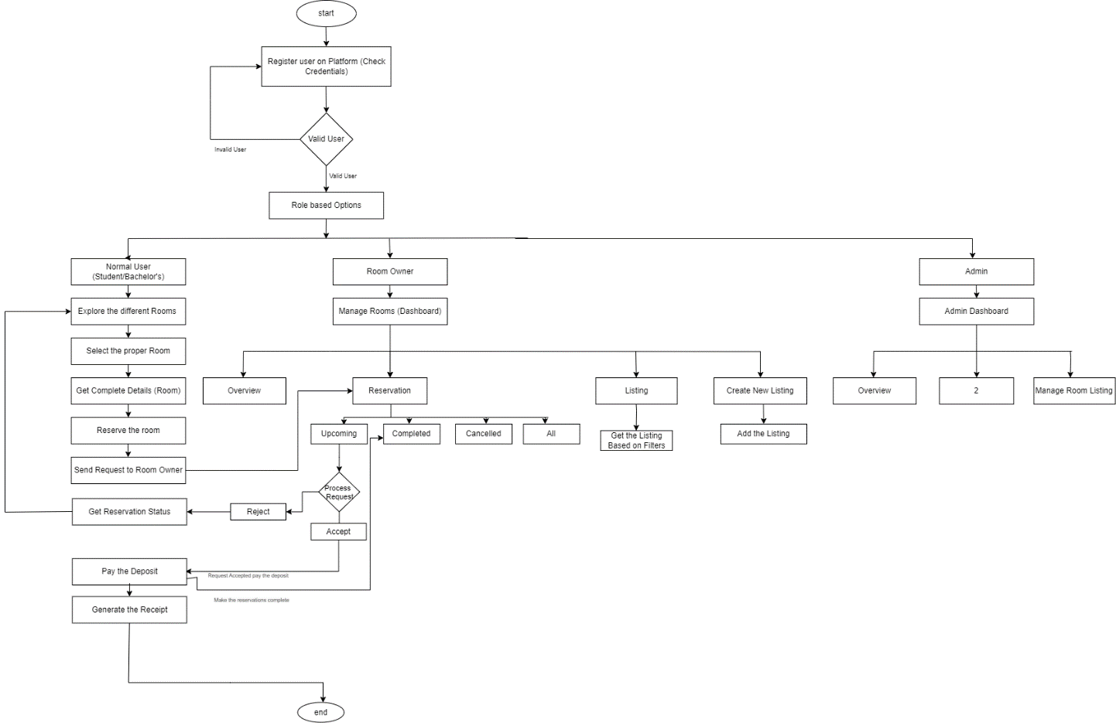

ApnaPG is a comprehensive platform designed to provide accommodation solutions for students and bachelors. The platform allows users to find and book various types of accommodations such as hostels, PGs, 1BHKs, 2BHKs, and houses. It also offers room owners a seamless way to manage their listings and reservations. Security is enhanced through mobile number and email verification, along with government ID validation.

**User Flow: Students and Bachelors**

1. **Home Page**

Display all available rooms with options to filter based on accommodation types: Hostel, PG, 1BHK, 2BHK, House.

Users can search rooms by location, check-in and check-out dates, and number of guests.

Featured listings and new arrivals are highlighted.

1. **Search and Filter**

Users enter search criteria (location, dates, guest number).

Filters refine results based on accommodation type, price range, amenities, and ratings.

1. **Detailed Room Listing**

Users click on a listing to view detailed information.

Details include title, description, images, amenities, location, and price.

Users can add rooms to their wishlist for future reference.

Users can see reviews and ratings from previous tenants.

1. **Wishlist Management**

Special dashboard for managing wishlists.

Users can view, remove, or book rooms from their wishlist.

1. **Booking Process**

Users select desired room and proceed to booking.

Enter personal details and verify mobile number and email.

Upload government ID for verification.

Confirm booking details and make payment.

Receive booking confirmation and details via email and SMS.

1. **User Dashboard**

Manage bookings: View current and past bookings, cancel or modify bookings.

Update profile and contact information.

Access support for any issues or inquiries.

**Room Owner Flow**

1. **Owner Registration**

Room owners sign up and create an account.

Verify mobile number, email, and upload government ID for security.

1. **Room Listing Management**

Special dashboard for room owners.

Add new listings: Enter title, description, upload images, specify amenities, location, and price.

Edit or remove existing listings.

View listing performance (views, bookings, reviews).

1. **Reservation Management**

Monitor room reservations in real-time.

Approve or decline booking requests.

View tenant details and booking history.

Update availability calendar to reflect occupied and available dates.

Communication with Tenants.

Built-in messaging system to communicate with potential and confirmed tenants.

Send updates or respond to queries directly through the platform.

1. **Payment and Earnings**

View earnings dashboard: Track payments received, upcoming payments, and total earnings.

Set up payment preferences and receive payouts.

1. **Verification Process:**

Both users and room owners must verify their mobile numbers and email addresses.

Government ID verification to ensure authenticity and enhance security.

Regular monitoring and validation of listings to prevent fraud.

1. **Secure Transactions**

Encrypted payment gateway to ensure secure transactions.

Regular security audits to protect user data and privacy.

ApnaPG aims to provide a seamless and secure accommodation solution for students and bachelors while offering room owners a robust platform to manage their properties. The step-by-step flow ensures ease of use, reliability, and security for all users.

**6. Technology adapted & Reasons for it.**

**Frontend:**

1. HTML,
2. CSS,
3. JavaScript
4. Framework:

**React.js**: A popular JavaScript library for building user interfaces, providing a component-based architecture and efficient rendering.

State Management:

Redux: For managing the global state of the application, especially useful in larger applications.

1. Styling:

Tailwind CSS is a utility-first CSS framework that allows developers to style web applications directly in the markup with predefined classes.

**Utility-First**: Apply styles directly within HTML elements.

**Customizable**: Configure and extend styles via a configuration file.

**Responsive Design**: Built-in responsive utilities for easy breakpoints.

**Component-Based**: Encourages reusable components for design consistency.

**Performance-Optimized:** Tools to purge unused styles for minimal CSS sizes.

**Backend:**

1. **Node.js with Express.js**: A robust and scalable server-side framework for building RESTful APIs.
2. **Database**:

**MongoDB**: A NoSQL database known for its flexibility and scalability, allowing for dynamic schema design and efficient handling of large amounts of data.

**Mongoose**: An Object Data Modeling (ODM) library for MongoDB and Node.js, providing a straightforward schema-based solution to model application data, enforce data validation, and manage relationships between data.

1. **Authentication**:

JSON Web Tokens (JWT): A method for secure and stateless authentication. JWTs are compact, URL-safe tokens that represent claims between two parties. They are often used to verify the identity of clients in a web application and to transmit information securely between parties. Being stateless, JWTs do not require the server to store session information, thus improving scalability and performance.

1. **Payment Gateway**:

Payment Processing: The Stripe API is used to handle payments securely. It provides a robust and scalable platform for processing online transactions, managing subscriptions, and handling various payment methods. Stripe ensures secure payment processing by encrypting sensitive data and complying with industry standards, making it a reliable choice for businesses to manage their financial transactions online.

1. **Security**:

User Authentication along with Adhar card Details

Use JWT (JSON Web Tokens) for secure authentication.

Implement secure password hashing (bcrypt).

1. **Input Validation**:

**Zod –** For the input validations at the backend side.

**Deployment:**

Hosting:

Netlify, Vercel, Onrender (Initial Stage)

AWS (Production Deployment)

7. Resources (Hardware & Software to be used):

**Hardware Used:**

1. **Processor**: 11th Gen Intel(R) Core(TM) i5-1135G7 @ 2.40GHz (up to 2.42 GHz)
2. **Installed RAM**: 8.00 GB (7.75 GB usable)
3. **System Type**: 64-bit operating system, x64-based processor
4. **Storage**: SSD 970 PRO NVMe M.2 512GB

**Software Used**:

1. Visual Studio Code (VS Code): A lightweight and powerful source code editor developed by Microsoft. It's highly customizable and supports various programming languages and extensions.
2. Git: A distributed version control system used for tracking changes in source code during software development. It's essential for collaborative development and managing project versions.
3. GitHub: A web-based platform for hosting and managing Git repositories. It provides tools for collaboration, code review, and project management, making it popular among developers for open-source and private projects alike.
4. Postman: A comprehensive API development environment that allows developers to design, test, and document APIs quickly and efficiently. It supports various request types, authentication methods, and automation features.
5. MongoDB Compass: A GUI (Graphical User Interface) tool for MongoDB that allows developers to interact with their MongoDB databases visually. It provides features for querying, analyzing, and managing MongoDB data, making it easier to work with databases.

# **Future Scope**

The accommodation solution for students and bachelors presented in this seminar report addresses the immediate needs of the target demographic. However, the future offers numerous opportunities for expansion and improvement in this domain. The following are potential areas for future growth and development:

**1) Chatbot Integration:**

Implement a basic chatbot using existing frameworks and libraries. Start with predefined responses for common queries related to accommodation search, pricing, and booking.

**2) Machine Learning for Recommendation:**

Begin with simple recommendation algorithms based on user preferences and historical data. Implement a basic system that suggests accommodations similar to what users have shown interest in.

**3) Geographic Expansion:**

Gradually expand the platform's coverage to nearby urban areas. This can be done by collaborating with accommodation providers in those regions and gradually increasing the database.

**4) Smart Contracts for Agreements:**

Explore existing blockchain platforms with smart contract functionality. Implement basic smart contracts for transparent rental agreements with standard terms and conditions.

**5) Augmented Reality (AR) for Virtual Tours:**

Start with basic AR features for providing virtual tours. Use existing AR libraries and frameworks to integrate simple visualization of accommodation spaces.

**6) IoT Integration for Smart Living:**

Integrate basic IoT devices such as smart locks or energy-efficient appliances. Begin with simple automation features that enhance security or energy efficiency.

**7) Advanced Security Measures:**

Enhance security gradually by implementing multi-factor authentication. Start with email or SMS-based verification for user accounts.

**8) Voice Search and Control:**

Begin with basic voice search functionality using available APIs. Allow users to search for accommodations and access basic information using voice commands.

**9) Community Engagement Features:**

Introduce basic community engagement features such as discussion forums. Allow users to share experiences and seek advice from the community.

**10) Green Living Certification:**

Collaborate with environmental agencies to define basic green living standards. Start by certifying accommodations that meet fundamental eco-friendly criteria.

**Project Timeline**

|  |  |  |  |
| --- | --- | --- | --- |
| **Sr. No.** | **Name of Phase** | **Description** | **Duration** |
| 1. | Requirement Gathering and Planning | Defining the project scope, objectives, requirements, and creating a project plan. | 1 Week |
| 2. | Analysis | Gathering and analysing the requirements, conducting feasibility studies, and Define system functionalities. | 1 Week |
| 3. | Design | Creating system architecture, Database design, UI/UX design and preparing the technical representations. | 2 Weeks |
| 4. | Development | Write code, develop features and integrate the components and components and conduct the platform for the testing. | 2 Weeks |
| 5. | Testing | Perform system testing, User acceptance testing (UAT), and identify the bugs. | 1 Week |
| 6. | Maintenance | Provide outgoing support, check for the security updates and additional features to integrate. | 1 Week |

**References**

1. Park, J. W., & Doo, K. I. (2019). Usability evaluation of social curation travel app for accommodation. *Journal of Advanced Research in Dynamical and Control Systems*, *11*(Special Issue 8), 2006–2012.
2. Nathan, R. J., Victor, V., Tan, M., & Fekete-Farkas, M. (2020). Tourists’ use of Airbnb app for visiting a historical city. *Information Technology and Tourism*, *22*(2), 217–242. <https://doi.org/10.1007/s40558-020-00176-0>
3. Chaudhari, K., Thakkar, A. A Comprehensive Survey on Travel Recommender Systems. *Arch Computat Methods Eng* 27, 1545–1571 (2020). <https://doi.org/10.1007/s11831-019-09363-7>
4. Bang Nong, N., & Ha, V. H. T. (2023). Impact of Covid-19 on Airbnb: evidence from Vietnam. *Journal of Sustainable Finance and Investment*, *13*(1), 283–296. <https://doi.org/10.1080/20430795.2021.1894544>
5. Wang, Z., Huang, W. J., & Liu-Lastres, B. (2022). Impact of user-generated travel posts on travel decisions: A comparative study on Weibo and Xiaohongshu. *Annals of Tourism Research Empirical Insights*, *3*(2). <https://doi.org/10.1016/j.annale.2022.100064>
6. Using mobile app for traveling: an example in Macedonia. (2018). *HORIZONS.A*, *23*. <https://doi.org/10.20544/horizons.a.23.2.18.p53>